HKU MoCap Studio Manuals v1.1

These manuals are meant to give an easy step-by-step guide for working with the Motion Capture system of the HKU. The manual can also be found online, together with all tools and example projects at the following page: <https://github.com/hku-ect/MOCAP_manual>

This document has manuals for working with the **Motive** control software, as well as using the **NatNet2OSC bridge** (<https://github.com/hku-ect/NatNet2OSCbridge> ) to stream live OSC data to other applications.

# This document contains the following manuals

### 01 Preparing the Motion Capture system

This manual explains how to startup the motion capture system, calibrate the cameras and create a new session with rigid bodies and/or skeleton data.

### 02 Preparing Motion Capture Data

This manual explains how to record, export and/or stream the motion capture data so you can use it in your own project

01 Preparing the Motion Capture system

This chapters describes how to prepare the Motion Capture system so it provides accurate data for your project.

## Starting up the Motion Capture system

Figure #1.1 shows a schematic setup of the MoCap system. 8 Infrared cameras (this may be more or less) are connected to a router, which connects to the main MoCap PC which runs the Motive control software. Motive can be used to record and export captured data, but clients can also connect to the Motive system via a network switch to receive data in real time.

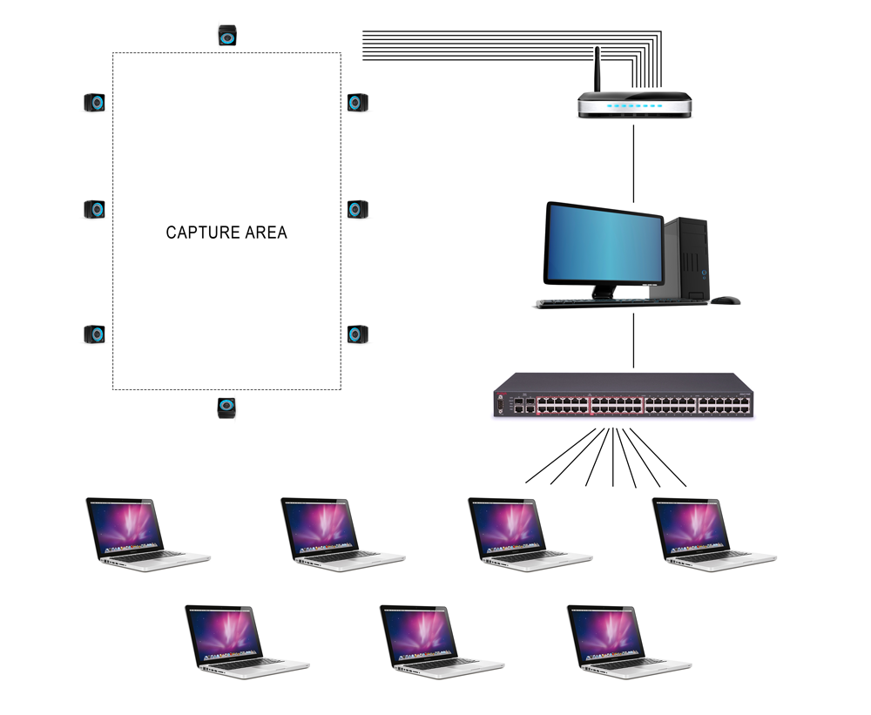

*Image #1.1: System schema*

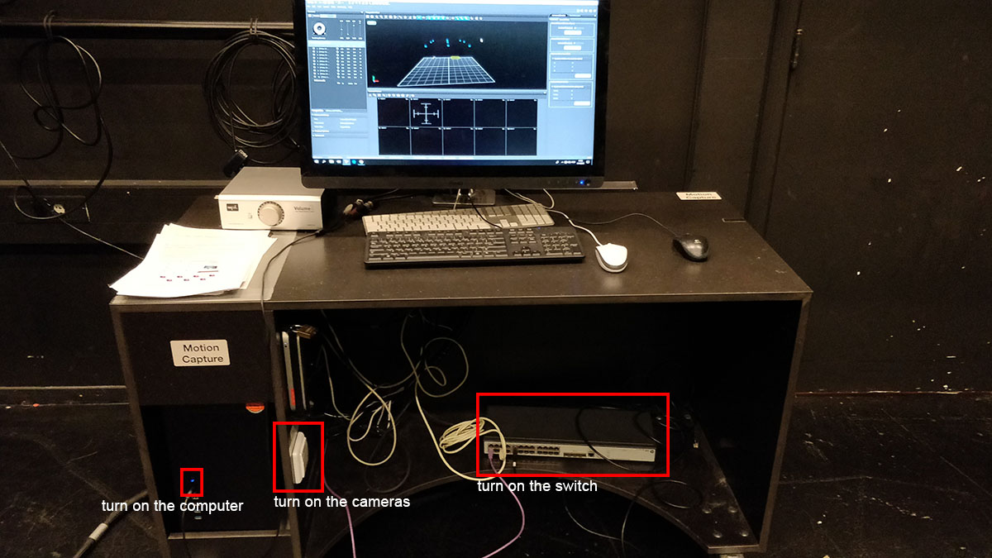

*Image #1.2: MOCAP computer*

Check if

* the cameras are turned ON (it can take up to 5 minutes to start the router/cameras)
* the switch is turned ON
* all cameras are connected to the router (the rings on the cameras should light up)
* the MoCap PC is connected to the router
* the MoCap PC is turned on

## Calibrate the system

### Step 1: Point the cameras

In the studio there are infrared cameras installed (image #1.2). Before you start, check if all the cameras point roughly towards the center of the area that you want to capture.

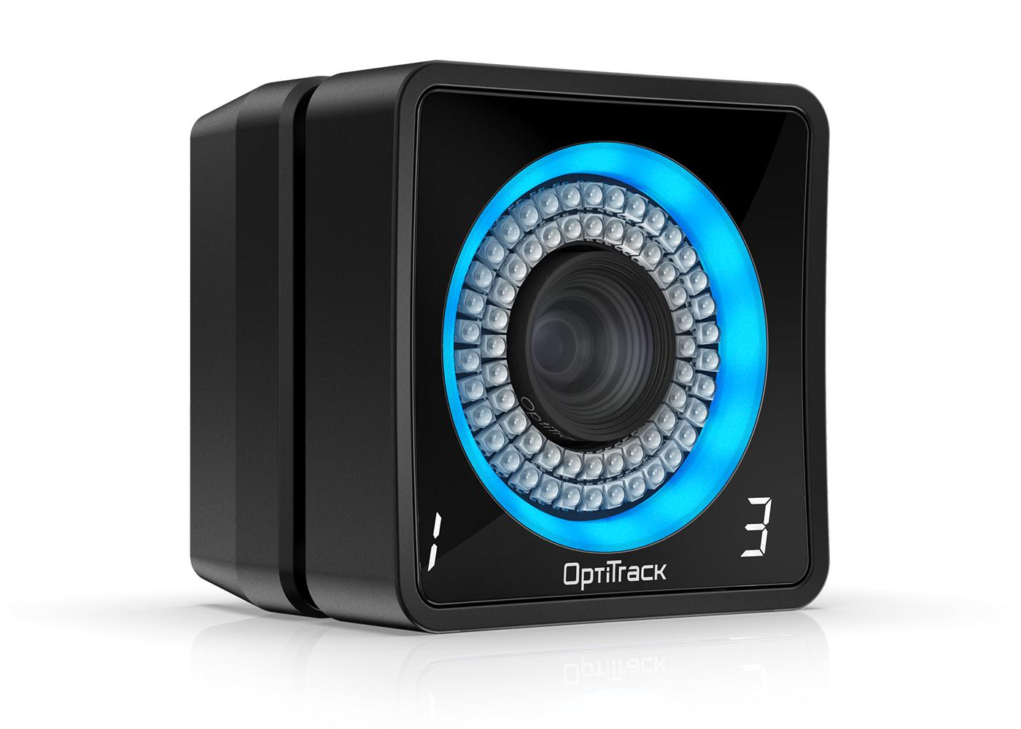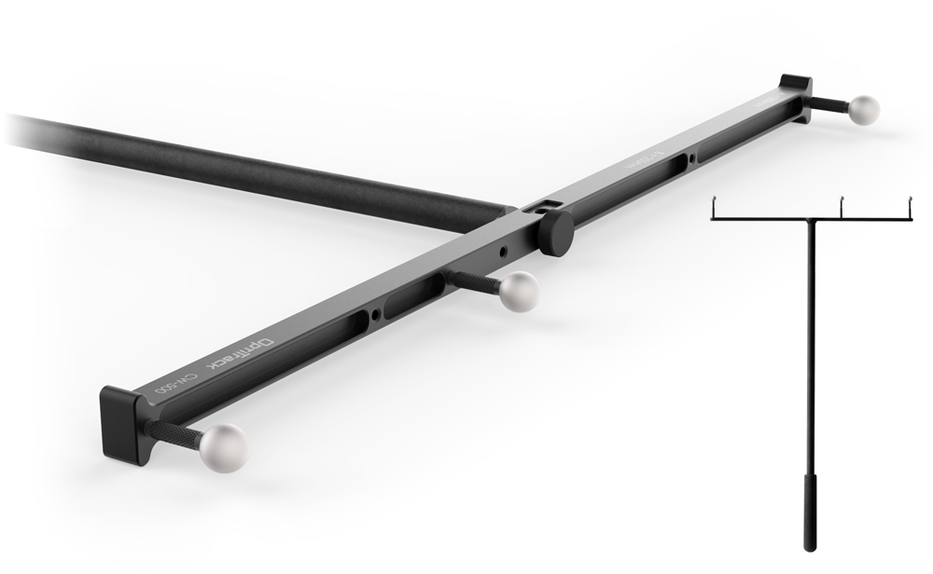 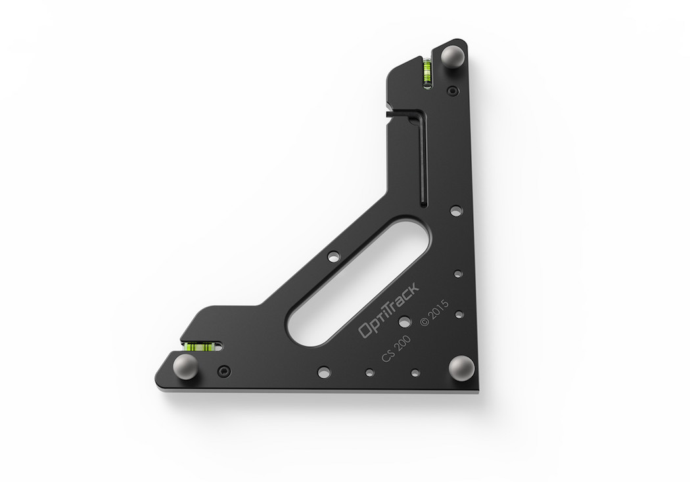

*Image #1.3: IR camera Image #1.4: The (Calibration) Wand Image #1.5: Ground Plane Markers*

### Step 2: Clear the area

* Open the Motive software on the MoCap PC
* In Motive go to Layout → Calibrate (image #1.5)
* Make sure the Capture Area is cleared and empty and that there are as few as possible objects lying around. Especially objects with reflective surfaces like chairs can interfere with the MoCap system.
* If the camera previews at the bottom of the Motive screen show any white spots;
  + Try to figure out which objects in the room are causing this. If possible remove the objects or cover them with non-reflective material, like a jacket or tape.
  + If all physical objects are hidden and there are still white spots in the previews screens, hit the **Mask Visible** button in the **Calibration** panel (top-right). All white spots should turn red.

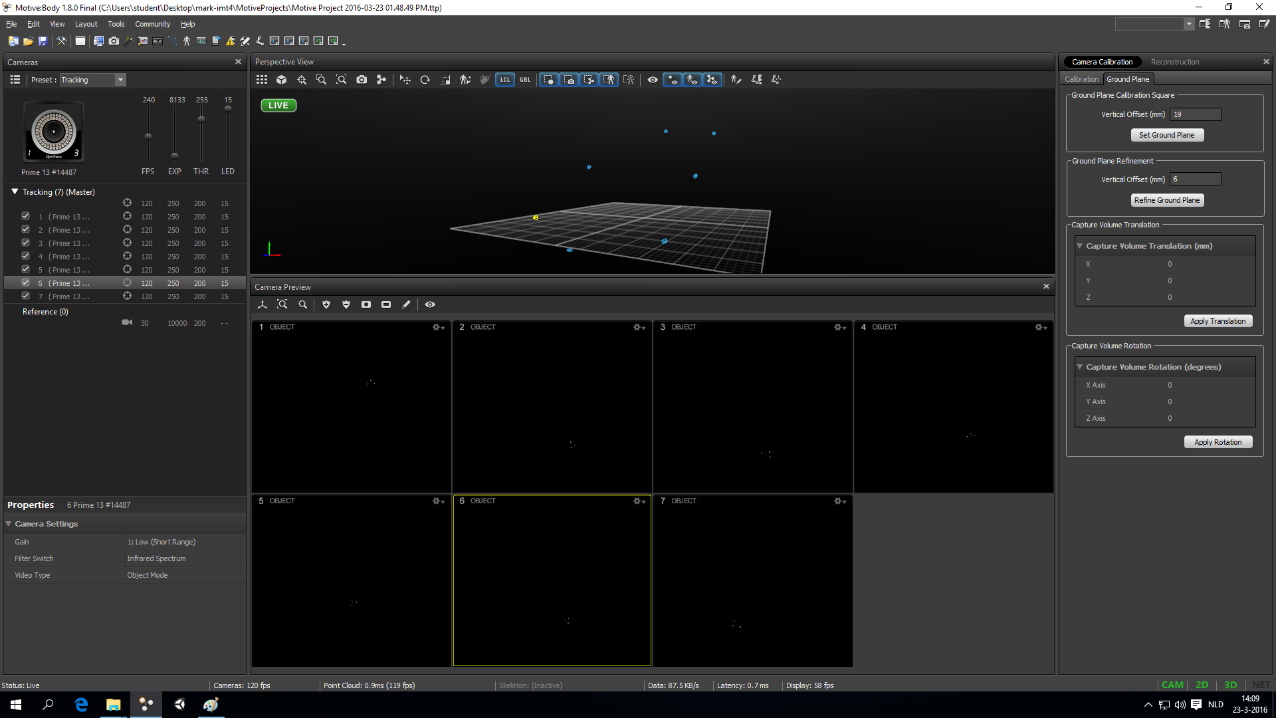

*Image #1.6: Calibration view*

### Step 3: Wanding

Motive needs to calculate the positions and orientations of the cameras. To do this, it needs as much as possible calibration data to compare the cameras to each other. The process of creating calibration data is called *wanding*.

* Assemble the wand (image #1.3)
* Press the **Start Wanding** button in the **Calibration** panel
* Keep *wanding* until the calibration panel is green, and all camera previews are covered with as much color as possible (image #1.6)
  + Walk around the capture area waving the wand around
  + Try to cover the entire volumetric area; lows, highs, centers, corners, edges, etc.
* If you can’t get any of the cameras to fill up, or you notice that the colors are showing up out of center, reset the calibration and start over from step 1;
  + you can hold the wand in the center of the Capture Area (at middle height) and use the white markers in the camera preview screens to check if the cameras are pointing in the right direction. The markers should show up in the middle of all the screens.
* If you have generated enough calibration data (image #1.6), click the **Calculate** button
* When the calculations are done and everything went well, motive should now show the cameras in the correct formation in the 3D view (image #1.7).
  + Don’t worry if the cameras are not straight above the floor, we’ll take care of that in the next step.

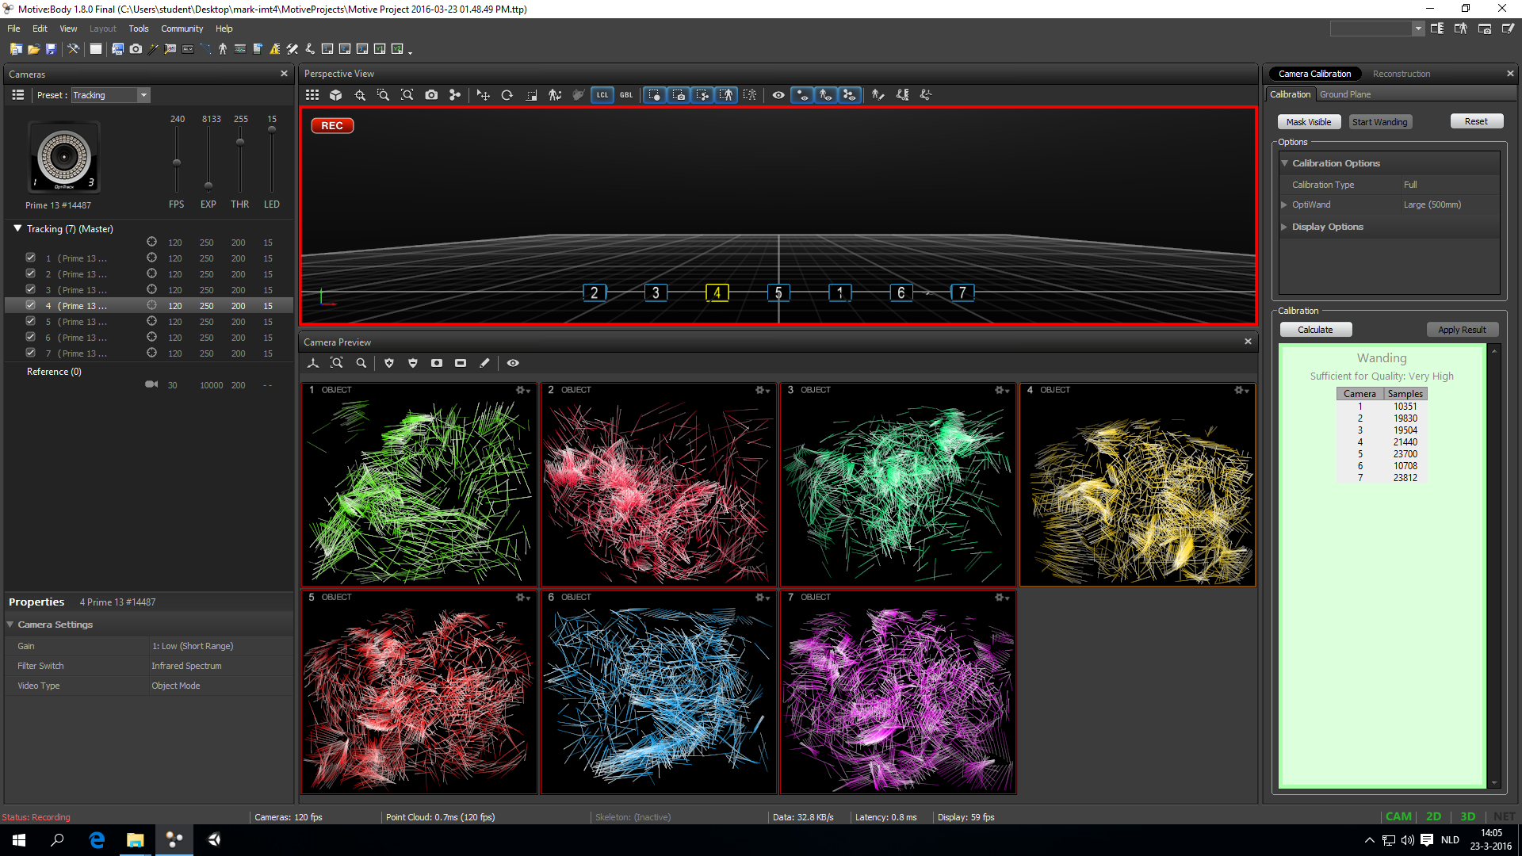

*Image #1.7: calibration screen during the ‘wanding’ process*



*Image #1.8: wanding done, ground plane incorrect*

### Step 4: Set the ground plane

Right now, Motive knows how the cameras are positioned and oriented *relative to each other*, but not yet relative to the rest of the world. The 3D view probably shows the cameras in the right formation, but tilted in relation to the floor (image #1.7). To fix this we have to set the *ground plane*.

* Take the **Ground Plane Markers** (image #1.4) and place them on the floor in the middle of the capture area (check if the markers show up in the camera preview screens)
* Make sure the long side points forward (this will become the z-axis of the 3D scene) and the short side points sideways (the x-axis)
* Hit the **Set Ground Plane** button in the **Ground Plane Panel** (top-right, image #1.7)
* The cameras should now show up straight above the floor in the 3D view

### Step 5: Test

The MoCap system is now calibrated and ready to be used. You can grab some markers (or use the wand) and move them around in the Capture Area. The markers should show up correctly in the 3D view in Motive. You might need to move/rotate/zoom the 3D view to see them.

For more detailed information on calibration, go to the optitrack Quick Start guide at:

<http://wiki.optitrack.com/index.php?title=Quick_Start_Guide:_Getting_Started#Camera_Calibration>

## Create Rigid Bodies

Motive can get the *position* of individual markers, but not the orientation (rotation). To calculate the orientation of an object, Motive needs at least 3 markers to be attached to the object in a fixed position.

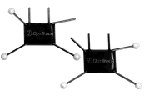 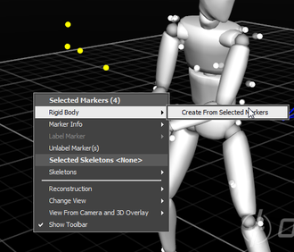 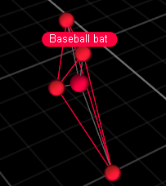

*Image #1.9: marker-set (for hands) Image #1.10: Select markers Image #1.11: RigidBody*

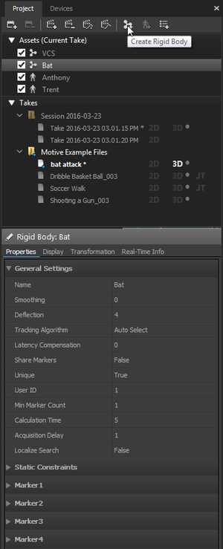

* Fix at least 3 markers (see for example image #1.8) to the object you want to track (this can be any solid physical object; a box, a whiteboard wiper, your hand, etc.)
  + Avoid using objects with reflective surfaces
  + Make sure the markers are positioned in a non-symmetrical formation
* Place the object inside the Capture Area
* In Motive go to **Layout → Create**
* Find the right markers in the 3D view (you might need to move/rotate/zoom)
* Select the markers in the 3D view (image #1.9)
* In the 3D view go to **Right Mouse Button** → **Rigid Body → Create From Selected Markers**
* In the 3D view the Rigid Body should show up as colored connected markers with a name (image #1.10)
* You can give the rigid body an appropriate name in the properties panel on the left (image #1.11)
* You can create as many rigid bodies as you need

*Image #1.12: Rigid Body Properties*

## Create a Skeleton

For tracking the movements of a human body you’ll need create a skeleton in Motive and dress your actor up in a mocap suit.

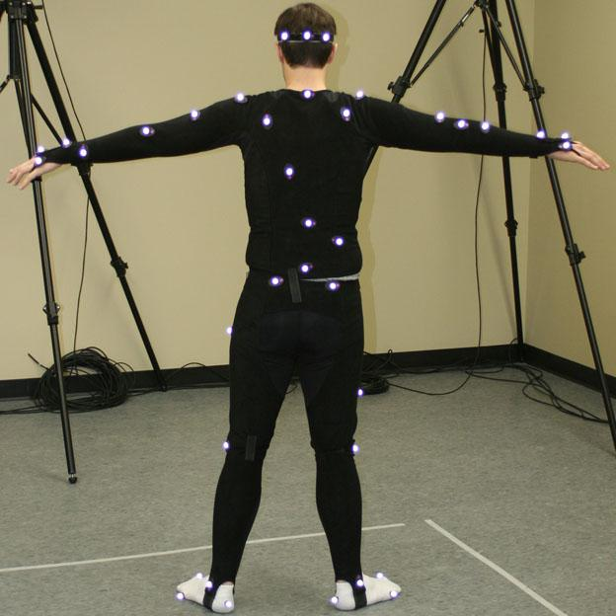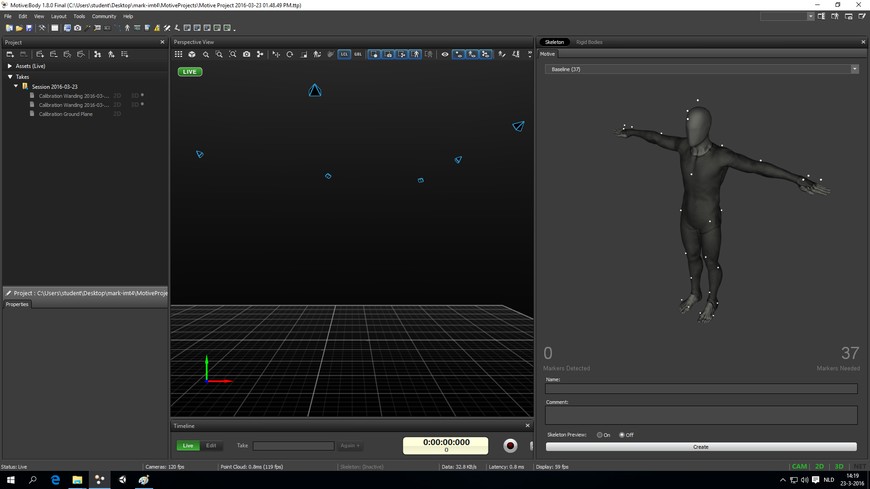

*Image #1.13: Mocap suit / T-pose Image #1.14: Skeleton Template / T-pose*

### Step 1: Pick a skeleton template

Motive provides a couple of *skeleton templates* that work well for full-body tracking.

* In Motive go to **Layout → Create**
* Choose a skeleton template from the skeleton panel (on the right, image #1.12)
* The skeleton panel shows;
  + how many markers you need (bottom right)
  + where each marker should go (you can rotate and zoom the image)
  + How many markers the system can currently see (bottom left)

### Step 2: Suit up!

* Put your actor in the velcro mocap suit and remove any markers that might still be attached to it (image #1.12)
* Attach the markers according to the Motive template. Work your way from top to bottom, or the other way around, to not miss any markers.
* If your actor is standing inside the Capture Area, motive shows how many markers it can currently find at the bottom left of the skeleton template panel (image #1.13).
  + Other objects or people might be blocking markers, so clear the area and let the actor move around to check your markers

### Step 3: Create, Name, Test

* When all markers are placed on the suit and Motive can find all of them, press the **Create** button at the bottom of the skeleton panel (image #1.13).
* A body should show up in the 3D View (image #1.14)
* Give the created skeleton an appropriate name

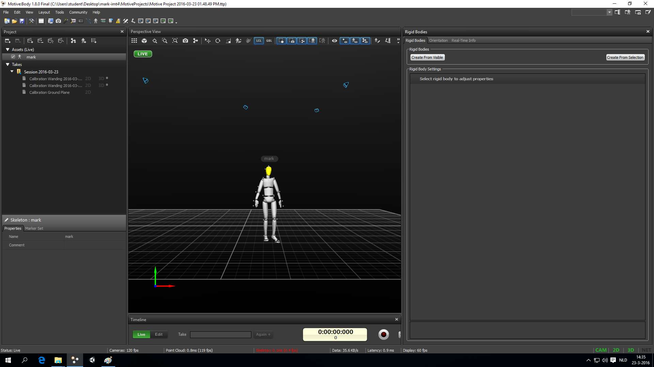

*Image #1.15: Skeleton, created & named*

The optitrack quick start guide has more in depth information about how to place markers (1) and how to create Rigid Bodies and Skeletons (2):

1. <http://wiki.optitrack.com/index.php?title=Quick_Start_Guide:_Getting_Started#Marker_Up>

2. <http://wiki.optitrack.com/index.php?title=Quick_Start_Guide:_Getting_Started#Define_Skeletons_and_Rigid_Bodies>

02 Preparing Motion Capture Data

This chapter assumes you have a working and calibrated motion capture system and you have created all the rigid bodies and/or skeletons that you need (see the *Preparing the Motion Capture system* manual for instructions).

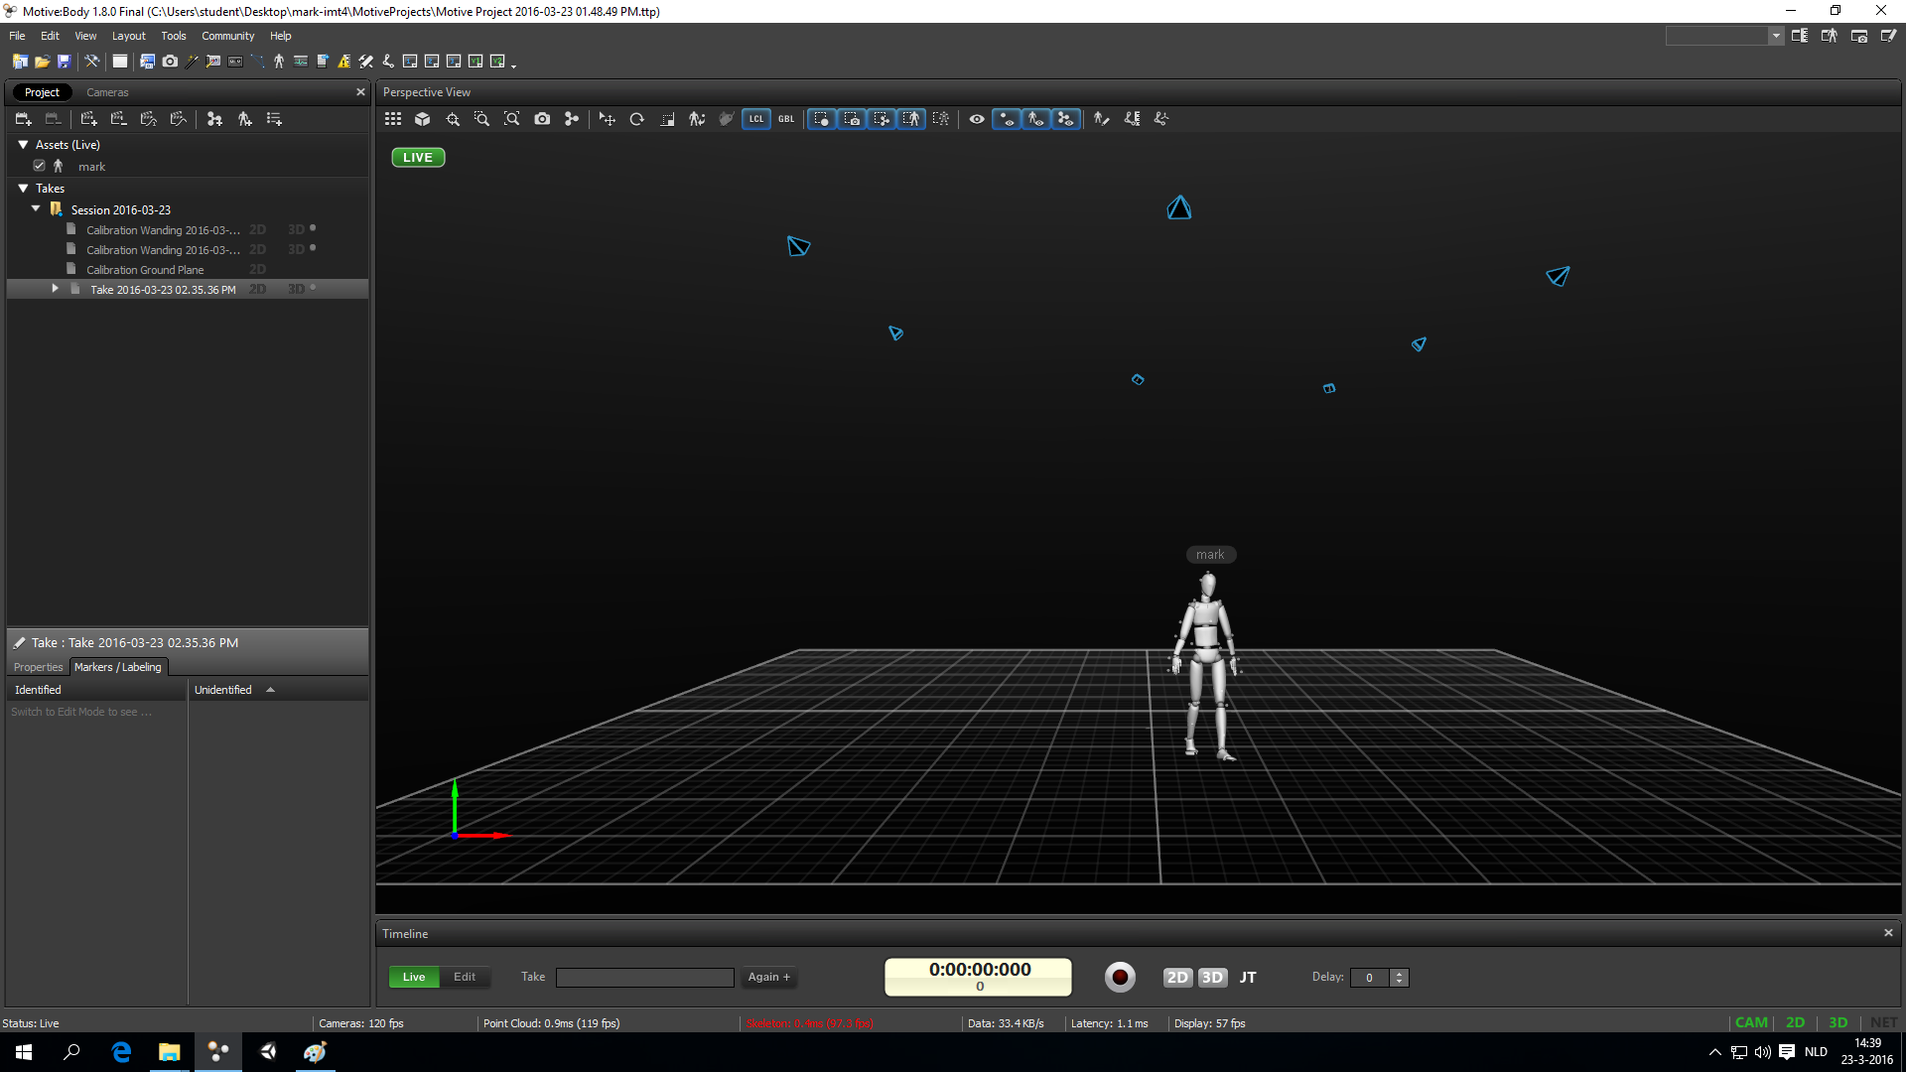

*Image #2.1: Capture Layout*

## Record tracking data

* In Motive, got to **Layout → Capture** (image #2.1)
* Check if everything looks good and your skeleton and/or rigid bodies are showing up correctly
* Practice all movements and check if everything looks good in the 3D view
* Any time if a skeleton in the 3D view looks strange, your actor can do a T-pose (image #1.12 and #1.13) to help Motive find the position of the skeleton
* In some cases certain markers might not be visible to enough cameras for Motive to track the motion. Try doing the movements in a different position or change your camera setup
  + Note that if you change the position of the cameras -even a little bit- you have to recalibrate the system
* To start recording, press the record button at the bottom of the screen (image #2.1). The timer starts running
* To stop recording, press the record button again. A new *take* shows up on the left (image #2.1)
* Double-click on a take to play it back and check if everything was recorded properly.

## Export tracking data

Motive can export the capture tracking data in various formats. Have a look at the Cinema4D use-case chapters of this manual to see which format you might want to use.

For working with skeletons and animating 3D models, you’ll most likely want to use the BVH format. See the Optitrack wiki on what kind of export fromats you can use (<https://v20.wiki.optitrack.com/index.php?title=Data_Export> )

For working with point clouds and trajectories, you might want to use the FBX format.

* Go to File → Export Tracking Data
* Choose the right format
* Export

## Stream tracking data

*Image #2.2: Data Streaming Panel*

Motive can both stream the live situation and pre-recorded sessions.

**To start streaming from Motive**

* Open the streaming panel via **View → Data Streaming**
* Make sure **Broadcast Frame Data** is enabled
* Check if **Local Interface** is set toa 192.168.10.* address.
* Make sure the following are enabled:
  + Stream Rigid bodies
  + Stream Skeletons
  + Skeleton As Rigid Bodies
* Under **Advanced Network Settings** check if
  + **Multicast Interface IP address** is set to **239.255.42.99**
  + **Port** is set to 1511

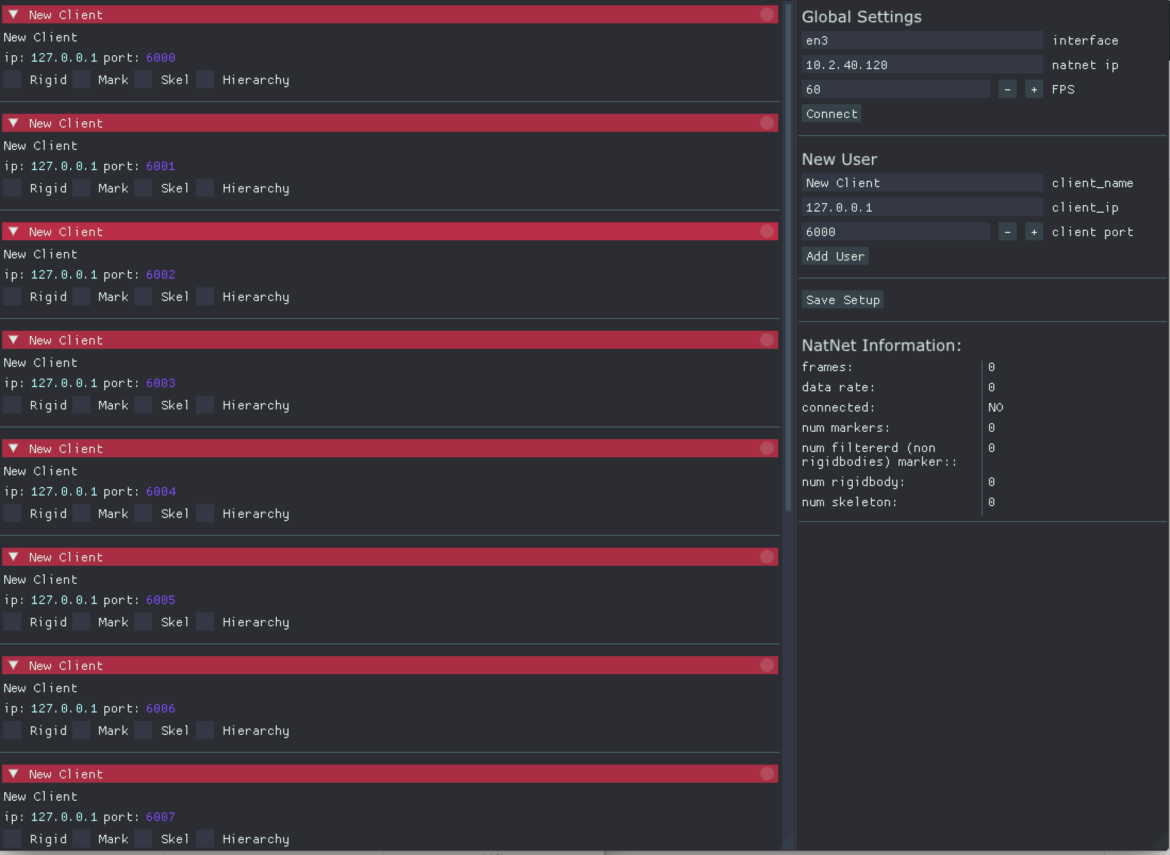**To start streaming OSC data to your computer**

* Start the Natnet2OSC bridge with the icon on the desktop.
* Under “Global Settings” click “Connect”.
* Connect your computer with a Ethernet cable to the MOCAP switch.
* Under “New User” add yourself as user filling in your IP address and the port on which you want to receive the data.

Changelog:

*V1.1 July 208:* edited manual to be more specific for current MOCAP studio at Oudenoord.